**Title:**

Isaak Salami

**Introduction**

For my half-semester placement, I worked under Dr Elena Colombi as part of her “*Functional integration of nitrogen-fixation in Australian indigenous rhizobia to improve soil fertility*” project. This project ultimately aims to identify the influence of genetic background on a soil bacteria’s ability to acquire and utilise rhizobia symbiosis genes. GENERAL BACKGROUND INFO on ICEsand IMEs

As Dr Colombi’s project is still in its initial stages, this placement involved on conducting preliminary tests and experiments with the aim to optimize the study’s experimental design. This was attempted from two different angles. First, to determine the symbiosis and nitrogen-fixing ability of *Mesorhizobium australicum* BR1-1-5xICE in different *Lotus* spp prior to the planned evolutionary experiment. Second, to determine a reliable method of confirming the presence of IME’s conferring symbiosis and nitrogen-fixation in *Pseudomonas* spp. Once confirmed, these bacteria would serve as donors to provide IME to non-symbiotic soil rhizobia via horizontal gene . As the IME is believed to carry copper (Cu) resistance gene, this study aimed to establish whether IME presence can be selected for by a Cu minimum inhibitory concentration (MIC) test.

CLOSING STATEMENT

**Methods**

***L. australis* and *L. corniculatus s*eed inoculation**

Four seed samples were selected for inoculation: Two samples of *L. australis* from Australia (L2 and L4), one sample of *L. corniculatus* from Italy (L3) and a sample of *L. corniculatus* from Australia (L5). Seed samples were supplied by Australian Pastures Genebank.

The seeds of *L. australis* and *L. corniculatus* were scarified by immersion in 98% pure sulfuric acid for 12 minutes, followed by five washes of sterile dH2O. Seeds were then immersed in 3.2% bleach for 20 minutes, followed by another five washes of sterile dH2O. Sterilised seeds were placed on fresh 0.8%(w/v) water agar and incubated in the dark at room temperature for 2 days. Successfully germinated seeds of L2 (n=9), L3 (n=4) and L4 (n=10) were transferred to test tubes with fresh 23mL Jansen agar slopes. Tubes were capped with foam plugs that allowed for gas exchange and incubated in the dark at room temperature for 2 days prior to inoculation.

*M. australicum* BR1-1-5xICE colonies from glucose Rhizobium Defined Medium (G/RDM) (no vitamin) plates were suspended in sterile dH2O and diluted to OD600 = 0.12 (2sf). 200µL aliquots of inoculum were pipetted directly onto seeds of L2 (n=6), L3 (n=3) and L4 (n=7). A subset of each seed Group was omitted from inoculation to act as negative controls (L2: n=3, L3: n=1, L4: n=3). Inoculated slopes were left to dry in lateral-flow cabinet for 40 minutes. Slopes (inoculated and negative controls) were wrapped in foil and transferred to a PC2 CO2 chamber incubate for 2 months.

**Nodulation assessment**

*L. rectus* (L8), L4 and L7 seeds were prepared and inoculated with *M. australicum* BR1-1-5xICE, using the same protocol as described above, by Dr Colombi prior to the initiation of my placement. The *L. rectus* seeds originated from Italy (L4 origin, L7 origin). All seeds were supplied by Australian Pastures Genebank The *L. rectus* group was incubated for 43 days prior to nodulation assessment. The sample set was composed three negative controls (L8-1, L8-2 and L8-3) and seven inoculated germinates (L8+1 – L8+7). The L4 and L7 groups were incubated for 62 days prior to nodulation assessment. The L4 group consisted of four negative controls (L4-1 – L4-4) and six inoculated germinates (L4+1 – L4+6). The L7 group consisted of three negative controls (L7-1 – L7-3) and seven inoculated germinates (L7+1 – L7+7). However, due to failures in root formation, L4-1 and L7+4 were omitted from the assessment.

*Lotus* spp. shoots were harvested by carefully removing them from the Jensen agar slope. Arieal cuttings of shoots of L4 and L7 were dried at 75ºC for 2 days, and 4 days for *L. rectus*, before weights were recorded.

Nodulation was assessed by counting and delimitating between well-developed nodules and smaller bumps presenting on the roots. Nodules were cut from the plant roots and separated based on host. In the case of L4+2 and L7 subjects, root cuttings displaying bumps were also harvested for analysis. In the case of L7, this was deemed especially appropriate as no subjects displayed fully-developed nodules, but a few possessed a considerable array of bumps.

Nodules were scarified by immersion in 80%(v/v) ethanol for 1 minute, then 3% bleach for 30 seconds, followed five washes of sterile dH2O. Nodules were then immersed in sterile dH2O and crushed with a sterile pestle. Loopfuls of nodule suspension were streaked onto G/RDM (no vitamin) plates and incubated at 28ºC for 5 days. Plates were then moved to 3ºC refrigerator for storage prior to colony assessment.

**Statistical analysis**

Analysis of the relationship between nodulation and dried weight was investigated using R Studio1 and Microsoft Excel2. Welch Two Sample t-test was used to assess the difference in nodulation count between inoculated plants and the negative controls. The Welch Two Sample t-test was also used to investigate the difference in dried mass between nodule-presenting (L8+2, L8+3 and L8+5) and negative control plants to assess for nitrogen fixation. The mean (±95%CI) dried masses of the the different treatment and nodulation groups (negative controls, inoculated, nodule-presenting, nodule and bump-presenting, bump-only) was used to construct a bar plot to further assess the effect of treatment and nodulation on dried mass.

**Colony assessment**

G/RDM plates inoculated with *L. rectus* nodule suspension were assessed after 6 days of refrigerator storage. Colony morphology was qualitatively assessed and compared across different plant samples.

**Cu MIC Assay**

*Trial I*

Four strains of *Pseudomonas* spp. were assessed in Cu MIC: *P. protegens* Pf5, *P. stutzeri* 17587, *P. stutzeri* 17641 and *P. stutzeri* Q. Strains 17641 and Q acted as positive controls (possess the IME) while strains Pf5 and 17587 acted as negative controls (lack the IME).

*P. stutzeri* strains were incubated at 28ºC on LB 1.5% agar media for 2 days, and *P. protegens* Pf5 for 1 day, prior to Cu MIC assay. Loopfuls of colony from each plate were resuspended in 10mM magnesium sulphate. Each cell suspension underwent a 1:10 series dilution to generate a set of solutions of decreasing concentration, with a range of 1:100 - 1:107. 20µL aliquots of each dilution were dispensed across a series of fresh Cu MGY 1.6% agar plates. Cu concentrations of 0mM, 0.8mM, 1mM, 1.3mM, 1.6mM and 2mM were used in for MIC assessment. The inoculated plated were incubated at 28ºC for 2 days prior to MIC assessment.

*Trial II*

Due to unexpected results from the first MIC and following a successful quality test of the Cu MGY 16% agar media, the MIC assay was repeated. The experiment was set up as described in *Trial I*, with an adjustment to the Cu concentrations in the media. This assay employed a range of 0mM, 0.3mM, 0.6mM and 1mM. Plates were incubated at 28ºC for 2 days, then moved to the 3ºC refrigerator for storage. Plates remained in the refrigerator for 2 days prior to assessment. Both qualitative and quantitative assessment of colony growth was recorded.

**Cu MGY media quality assessment**

Following unexpected results in Cu MIC *Trial I*, a quality control assay was conducted to determine if the odd results were a result of poor plate preparation

Control colonies were sampled from previously-prepared cultures supplied by another member of the EMMA lab group (NEED TO GET HER NAME). For a negative control, 8 colonies of the Cu-sensitive phyllosphere culture "Phyllo B" grown on 0mg/L Cu *Pseudomonas* Selective Media (PSM) were randomly selected. For positive controls, 3 colonies from the "Phyllo-C" phyllosphere culture grown on 300mg/L Cu (equiv. to 4.72mM) PSM, 3 colonies from the "Phyllo-C" phyllosphere culture grown on 200mg/L Cu (equiv. to 3.15mM) PSM, and 2 colonies from the "Rhizo-C" rhizosphere culture grown on 200mg/L Cu PSM were randomly selected. The positive and negative control colonies were streaked on 0mM, 0.8mM and 1.0mM Cu MGY 1.6% agar plates (from *Trial I* plate preparation). Plates were incubated at 28ºC for 2 days prior to growth assessment.

***Lotus* spp growth conditions**

* All *Lotus* spp seedlings were incubated in a PC2 CO2 incubation chamber. CO2 level: general atmospheric conditions. Relative humidity: 70%. Day/Night cycle: Day: 16hrs, 22ºC, standard white light. Night: 8hrs, 14ºC, no light. No watering needed.

**Media preparation**

*Jensen media* (per 1.00L): CaHPO4 (1.00g), K2PO4 (0.20g) MgSO4⸳7H2O (0.20g), NaCl (0.10g), FeCl3 (0.10g), Agar (12.0g).

*0.8% water agar* (per 400mL): Agar (3.2g)

*G/RDM (no vitamin) media* (per 200mL): L-Histidine (20.0mg), G/RDM salts (2.5% MgSO4⸳4H2O, 0.2% CaCl2⸳2H2O, 0.7% FeEDTA, 2% NaCl) (2.00mL), 0.2% Bromothymol-Blue (2.00mL), 1.8% NH4Cl (1.15mL), Agar (3.20g), “Trace Elements 4 GRDM” (200µL)

*Cu (xmM) MGY media* (per 600mL): Mannitol (6.00g), L-glutamic acid (1.20g), KH2PO4 (0.30g), NaCl (0.10g), 1.0M KOH (adjusted to pH 7.0), Yeast Extract (0.15g), Agar (9.6g), 1.0M CuSO4 (100µL per 1mM concentration required)

**Results**

**Colony assessment**

All plates inoculated with the nodule suspension prepared from subjects L8+2, L8+3 and L8+5 displayed bacterial growth. Each isolate possessed a similar morphology of green ill-defined wet colonies, with no secondary isolates or contaminants observed. The fact colonies appeared identical across nodules from all three assessed plants is strong evidence that the recovered isolate is the same bacteria used in the initial seedling inoculation, *M. australicum* BR1-1-5xICE. This displays that the bacteria was able to successfully utilise the symbiosis genes of the ICE to colonise the roots of *L. rectus*.

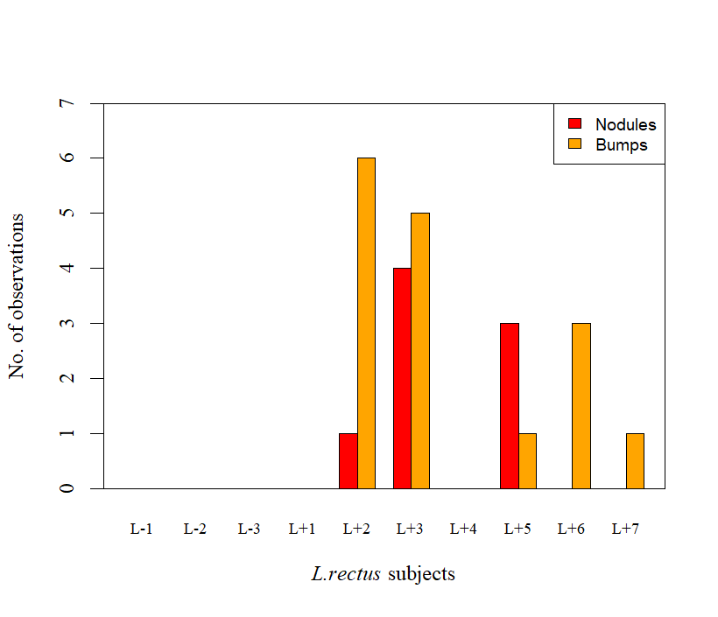

**a**

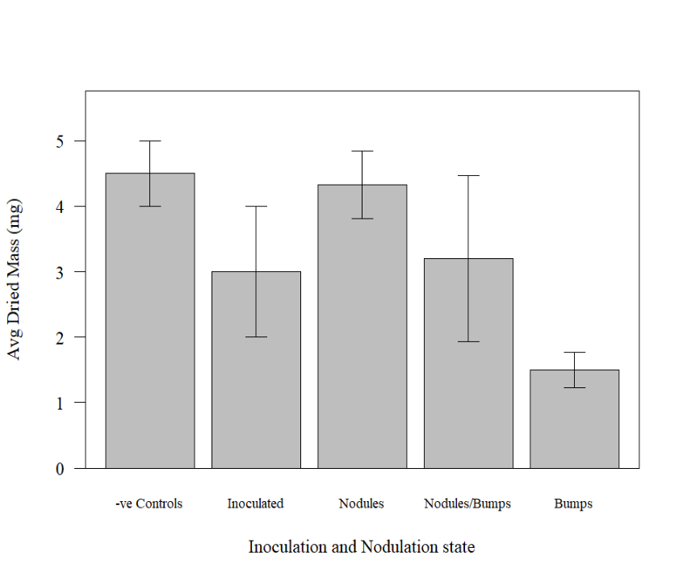

**b**

**Figure 1**. Nodulation assay results **a)** Count of well-developed nodules and underdeveloped bumps for each *L.rectus* subject. Nodules and bumps were only observed on the inoculated subjects, as expected. However, the difference in nodulation between the inoculated and the negative control groups is not statistically significant, according to a Welch Two Sample t-test (p=0.1212, t5=1.865) **b)** Average dried weights (±95%CI) of *L. rectus* aerial cuttings sorted by inoculation type (-ve Control & Inoculated) and nodulation type (Nodules, Nodules/Bumps, Bumps). The negative control group had a greater average mass than the inoculated subjects, however these inoculated plants displayed a greater range of masses. *L. rectus* plants displaying nodules showed now statistically significant difference in mass to the negative control group (p=0.852, t0.2=0.852).

**Nodulation assessment**

*L. rectus*

Of the seven *L. rectus* seedlings inoculated with *M. australicum* BR1-1-5xICE, only five displayed any signs of rhizobia symbiosis. All five presented with small orange bumps, which may be evidence of the beginnings, or an attempt, at nodulation (CITATION?). Of these five, only three plants presented with developed nodules (L8+2: 1, L8+3: 4, L8+5:3) (**Figure 1.a**). In contrast, none of the three negative control plants displayed any nodules or bumps. However, when only considering nodule count, there was found to be no statistically significant difference between the negative controls and the inoculated plants (p=0.1212, t5=1.865).CUT THIS?

The dried weights of the negative controls appeared reasonably consistent, with a range of 3.5mg-5.0mg. The dried weights of the inoculated plants also displayed minimal variation, with a range of <1mg-5mg (**Figure 1.b**). Comparison between nodule-presenting subjects and the negative controls revealed no statistically significant difference in dried mass of the aerial cuttings (p=0.852, t0.2=0.852).CHANGE TO NODULE PRESENTING VS NON-PRESENTING This absence of mass difference indicates that the symbiotic *M. australicum* BR1-1-5xICE did not provide its plants with nitrogenous compounds. Thus, it appears that the bacterium was incapable of utilising the N+ genes of the ICE.

*L4*

Of the seven *L4* seedlings inoculated with *M. australicum* BR1-1-5xICE, only four displayed any signs of rhizobia symbiosis. Two subjects (L4+2 and L4+7) presented with 1-2 small green bumps, which may be evidence of the beginnings, or an attempt, at nodulation (CITATION?). Three subjects presented with developed nodules (L4+2: 1, L4+6: 2, L4+7:1) (**Figure 1.a**). Unlike *L. rectus*, only one of the L4 nodule-presenting plants also displayed a bump (L4+7). In contrast, none of the three negative control plants displayed any nodules or bumps. However, when only considering nodule count, there was found to be no statistically significant difference between the negative controls and the inoculated plants (p=,).CUT THIS?

The dried weights of the negative controls. The dried weights of the inoculated. Comparison between nodule-presenting subjects and nodule-lacking subjects revealed...

*L7*

Of the seven *L7* seedlings inoculated with *M. australicum* BR1-1-5xICE, no subjects displayed fully-developed nodules. However, four subjects displayed a series of small orange bumps (L7+2: 10, L7+3: 10, L7+4 26, L7+5: 9). The frequency of these bumps suggests multiple attempts at forming a symbiosis, but none of which were particularly successful (CITATION?). In contrast, none of the three negative control plants displayed any bumps. When considering bump count, there was found to be no statistically significant difference between the negative controls and the inoculated plants (p=,).CUT THIS?

The dried weights of the negative controls. The dried weights of the inoculated. Comparison between nodule-presenting subjects and nodule-lacking subjects revealed...

Lotus *spp. comparison*

**Cu MIC Assay**

**Table 1**. Cu MIC *Trial II* results. MIC measures are based on the 1:107 diluted inoculation patch of each bacteria’s series dilution. The *Pseudomonas* species of the “strains” listed refer to *P. protegens* for Pf5, and *P. stutzeri* for 17578, 17641 and Q. Strains 17641 and Q are carries of the IME of interest, while Pf5 and 17578 are negative controls.



*Trial I* of the Cu MIC assay produced unexpected results. While the displayed good growth on the 0mM plate, no growth was observed on plates with Cu ≥ 0.8mM. However, the subsequent quality assessment of the media went as expected. The Cu-tolerant colonies sampled from Phyllo-C (grown on Cu 300mg/L), Phyllo-C (grown on Cu 200mg/L), and Rhizo-C (grown on Cu 200mg/L) all displayed good growth on 0mM, 0.8mM and 1.0mM plates. Moreover, the Cu-sensitive "Phyllo B" colonies grew well on the 0mM plate, but displayed minimal to no growth on the 0.8mM and 1.0mM plates, as expected. (See Supplementary?). These results display that absence of growth in *Trial I* was not the result of faulty MGY preparation, but instead an indication that the lowest Cu concentration of 0.8mM was above the Cu tolerance level of the isolates.

*Trial II* of the Cu MIC also produced unexpected, albeit interpretable, results. As displayed in **Table 1**, the four strains varied in their tolerance to Cu. When comparing the most diluted inoculation patch of the dilution series, 1:107, *P. protegens* Pf5 displayed the greatest resistance (MIC: 0.6mM), followed by *P. stutzeri* 17587 and *P. stutzeri* Q (MIC: 0.3mM), then *P. stutzeri* 17641 (MIC 0.0mM). These results support the hypothesis that the absence of growth in *Trial I* was largely due to testing Cu concentrations above the tolerance level of the isolates. However, it is important to note that while no dilution patches grew on any plates with Cu ≥ 0.8mM, some of the more densely concentrated inoculation patches for *P. protegens* Pf5, *P. stutzeri* 17587 and *P. stutzeri* Q displayed MIC’s of >1.0mM.(See Supplementary?). *P. stutzeri* 17641 also displayed MIC’s of 1.0mM for some of its more densely concentrated patches .(See Supplementary?). Therefore, an error in plate preparation for *Trial I* may be partially to blame for these inconsistencies.

It should be noted that the Trail II MIC for *P. stutzeri* 17641 was complicated by contamination…

**Discussion**

**Conclusions**

**Data Management Plan**

**References**

1. Posit team. RStudio: Integrated Development Environment for R. Posit Software, PBC (2025).

2. Microsoft® Excel® for Microsoft 365 MSO 64-bit. Microsoft Corporation.